**LABORATORY 3**

Group components: Albert Bausili Fernández, Noa-Yu Ventura Vila

Group identifier: par2301

10/11/2022

**Index**

**1. Task decomposition analysis for the Mandelbrot set computation**

**1.1 Unflagged execution of mandel-tar.c**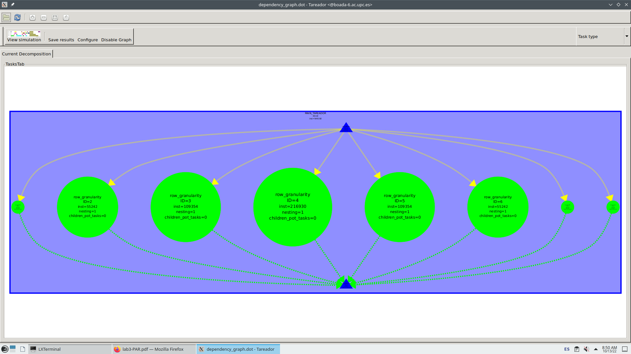



1.1.1 Graph Analysis

We executed the program mandel-tar without flags using *Tareador* and got its task dependence graph shown in figure 1, from which we can deduce a few things. There are 8 tasks in total because there are 8 rows in the matrix, and it makes sense because we changed the code in order to get a task for each iteration of the row loop. Since they are all on the same level we know the code is highly parallelizable, even though some tasks need to wait for the heaviest ones to finish their execution in order to proceed with the program.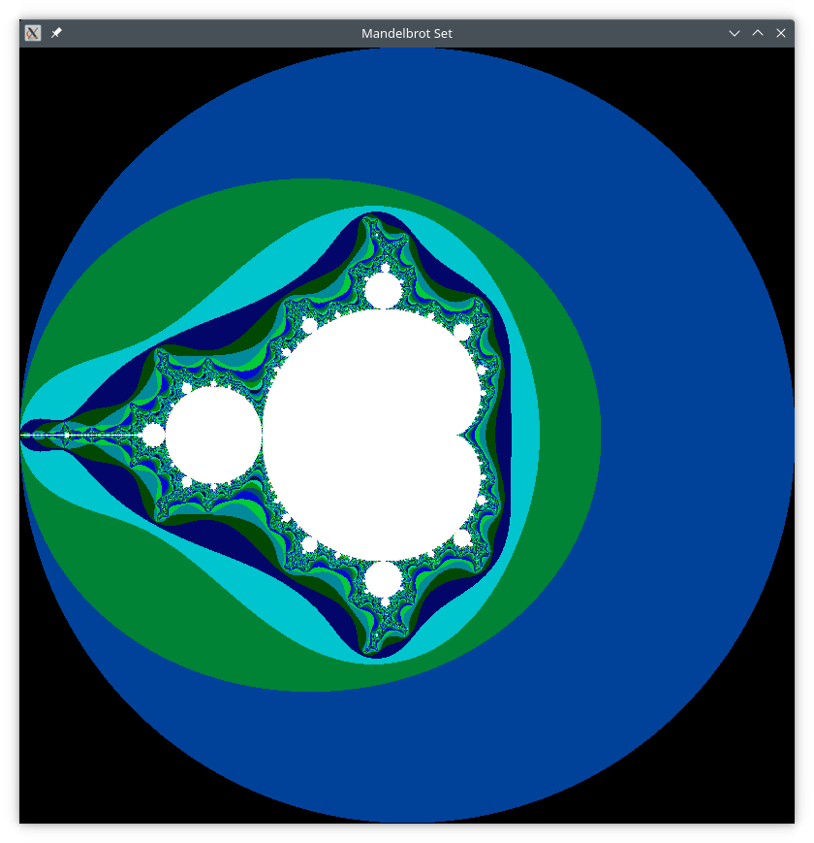

From the size of each bubble that contains a task we can see that there is a big imbalance between the eight tasks, which is due to the different convergence times of each row of points, being the central ones the heaviest. This matches the results we get from the execution of mandel-seq (see figure 2), because the colors represent the convergence time for each of the points.

The colors in the middle are white while the ones outside the biggest circumference are black, which means that the convergence times of the rows of points in black are extremely low (value of k might be 0 or 1) and the white ones have an extremely high time convergence (value of k is equal or close to the arbitrary value determined to stop the *do-while* loop). Points with higher convergence time match the tasks with a higher weight in the program, so the results from both executions match the expected output.

**1.2 Execution of mandel-tar.c using flag -d**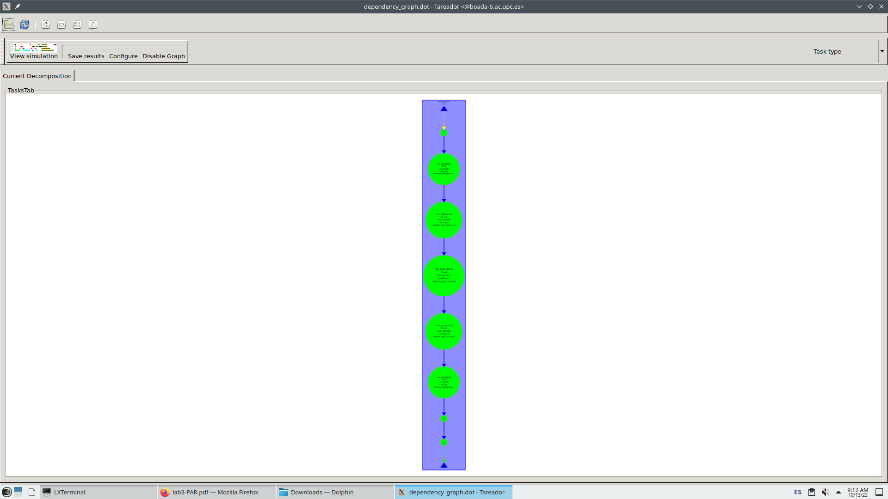



1.2.1 Graph Analysis

Figure 3 corresponds to the mandel-tar execution for *Tareador* using the flag -d. We can see that, unlike the previous task dependence graph, this one shows the tasks sequentially, but their size is still the same as before so the imbalance is unchanged.

1.2.2 Serialization discussion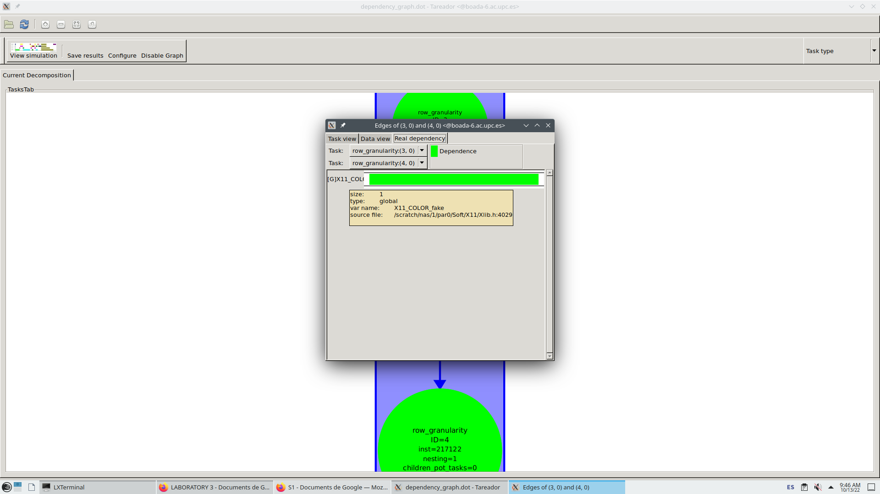

In order to know what is causing this serialization we checked in the edges of the graph the real dependency. We found out a global variable, which *Tareador* named X11_COLOR_fake, is causing the dependencies between all the tasks, which makes them be executed sequentially even though they are parallelizable. This is shown in figure 4.

The fragment of the code below in section 1.2.3 is only executed when the option -d is chosen. The functions inside the if condition are from a library, one of which writes pixel for pixel the display. This is done sequentially, that’s why it takes so much time to execute the program when using the -d option and the reason why *Tareador* shows us the parallelizable tasks now depend on another one.

1.2.3 Solution to serialization with OpenMP

Writing #pragma omp nowait is the solution to this problem, which is also shown in the code below. With this solution *Tareador* shows us the same task dependence graph as executing mandel–tar without options, where all tasks are parallelized. See the code below to check the solution.

…

if (output2display) {

/* Scale color and display point */

long color = (long) ((k-1) * scale_color) + min_color;

if (setup_return == EXIT_SUCCESS) {

#pragma omp critical

{

XSetForeground (display, gc, color);

XDrawPoint (display, win, gc, col, row);

} } } …

**1.3 Execution of mandel-tar.c using flag -h**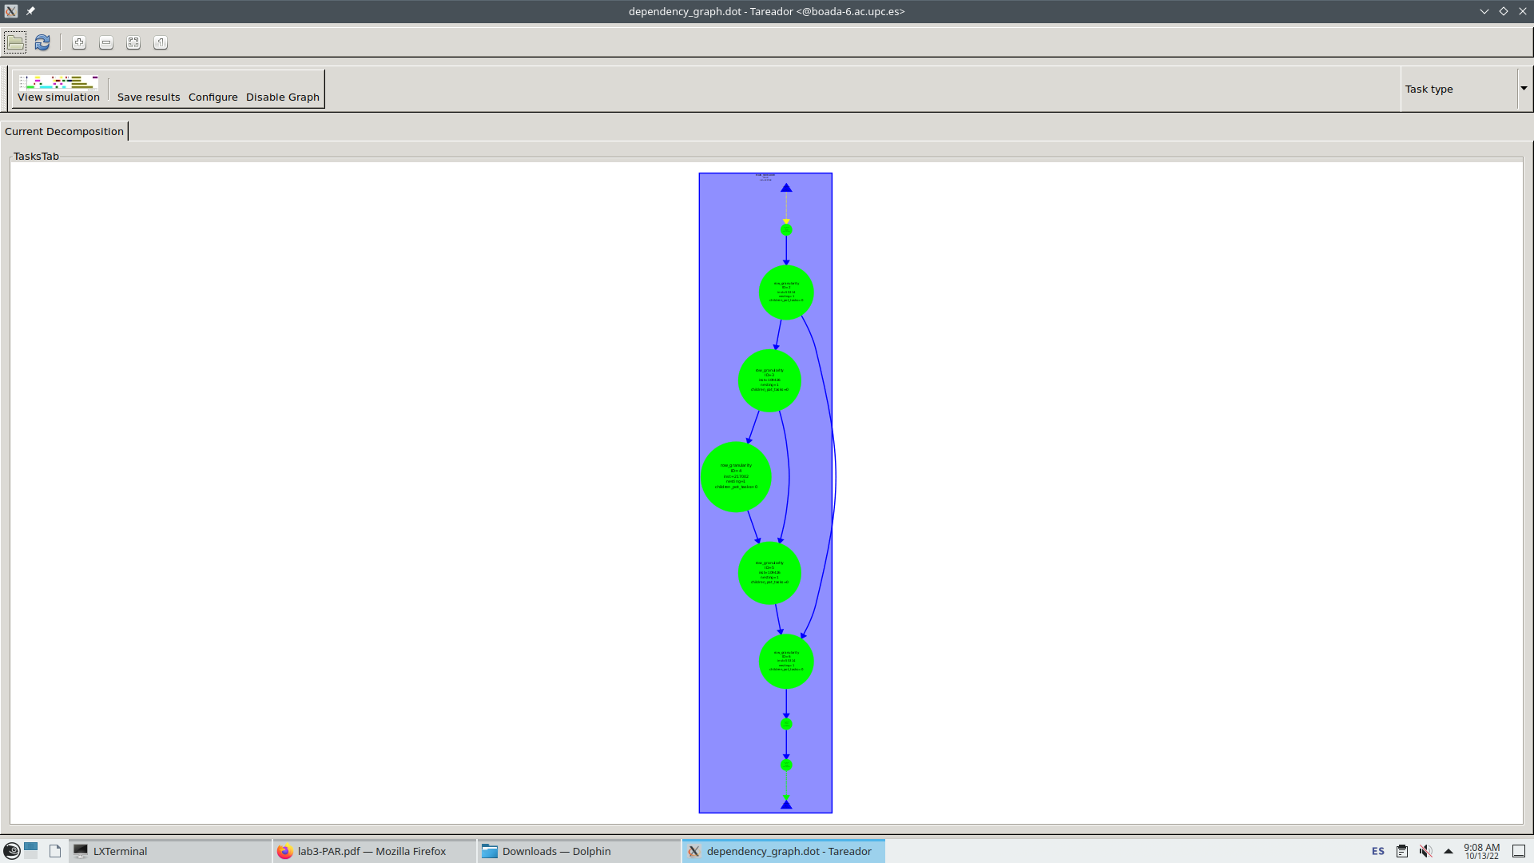

1.3.1 Graph Analysis

This is the same situation as using flag -d, there’s a variable that makes parallelizable tasks depend on another one, making the execution of our code sequential. The difference now is that, even though the code is also executed sequentially, some of the heavier tasks depend on another heavy task. This is shown in figure 5, where each chain of tasks represents the dependencies between the accesses to histogram[k-1].

1.3.2 Serialization discussion

We followed the same logic for this task dependence graph for option -h and checked its edges. In this case, the variable that makes the code sequential is named uncast of type heap (see figure 6 below).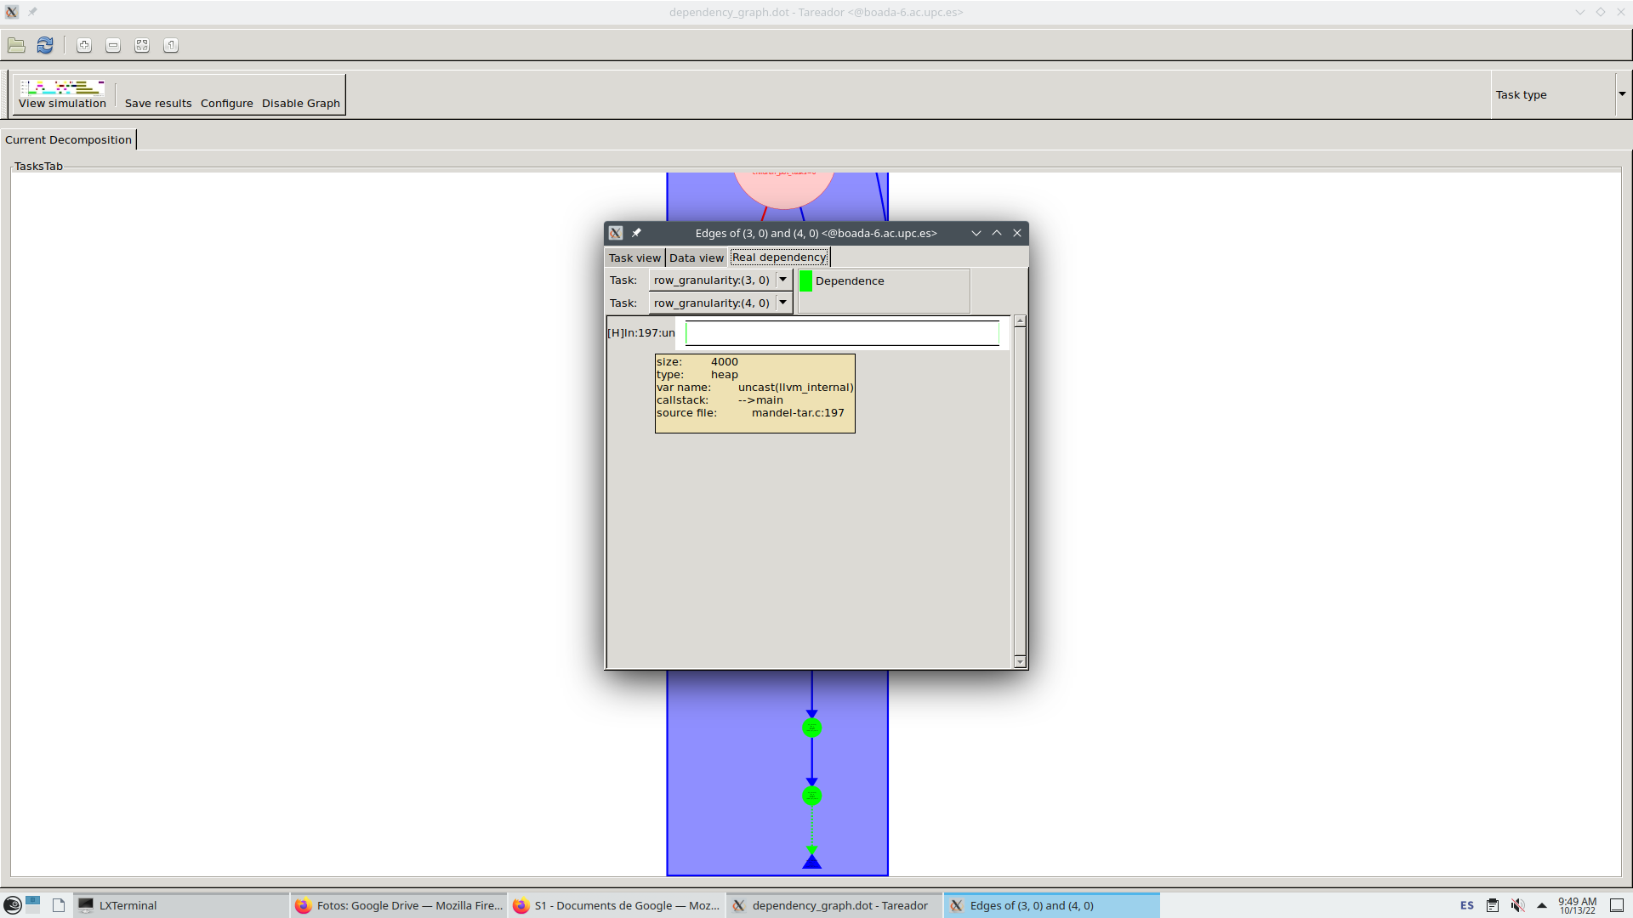

Reading the code we see a portion that is only executed when option -h is used, and this is verified with variable output2histogram. It makes the execution be sequential, because we access the vector histogram sequentially one position after the other.

1.3.3 Solution to serialization with OpenMP

The way to solve this sequencing is

…

// Calculate z0, z1, .... until divergence or maximum iterations

int k = 0;

double lengthsq, temp;

do {

temp = z.real*z.real - z.imag*z.imag + c.real;

z.imag = 2*z.real*z.imag + c.imag;

z.real = temp;

lengthsq = z.real*z.real + z.imag*z.imag;

++k;

} while (lengthsq < (N*N) && k < maxiter);

output[row][col]=k;

if (output2histogram) histogram[k-1]++;

…

**2. Point strategy**

Point strategy executes a task for every column of each row in parallel. This is possible with the clause #pragma omp task firstprivate(row,col) as shown in the code below.

…

#pragma omp parallel

#pragma omp single

for (int row = 0; row < height; ++row) {

for (int col = 0; col < width; ++col) {

#pragma omp task firstprivate(row, col)

{

complex z, c;

…

//escriure peu de foto, figure #. explicacio: Simplest tasking code for Point granularity

**2.1 Unflagged execution of mandel-tar.c**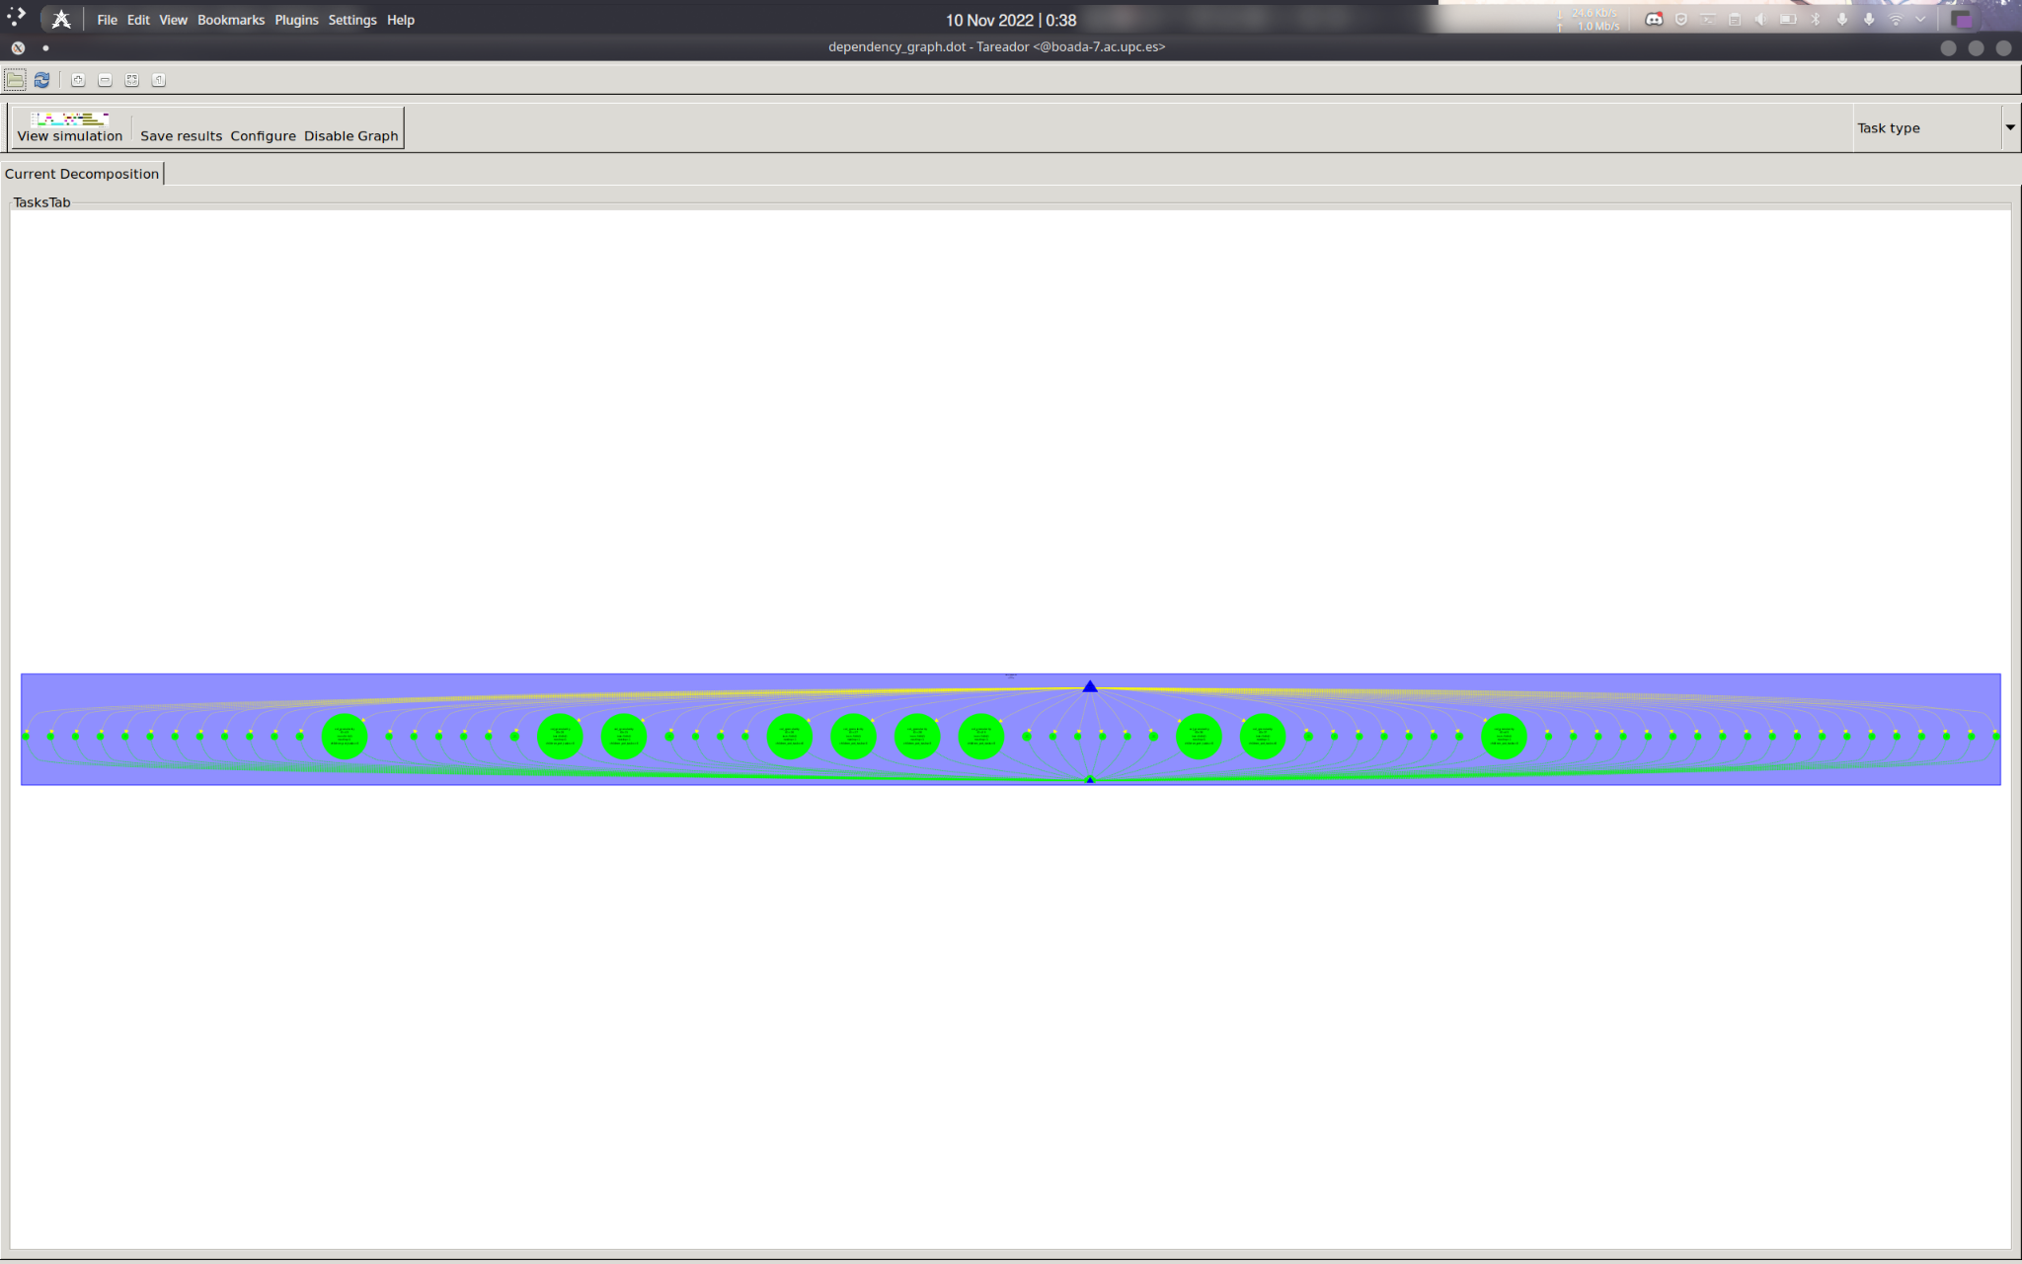



//canviar el numero de la figura i especificar que es pel point strategy. sha de fer per totes les fotos seguents

2.1.1 Graph Analysis

We executed the program mandel-tar without flags using *Tareador* and got its task dependence graph shown in figure 1, from which we can deduce a few things. There are 8 tasks in total because there are 8 rows in the matrix, and it makes sense because we changed the code in order to get a task for each iteration of the row loop. Since they are all on the same level we know the code is highly parallelizable, even though some tasks need to wait for the heaviest ones to finish their execution in order to proceed with the program.

From the size of each bubble that contains a task we can see that there is a big imbalance between the eight tasks, which is due to the different convergence times of each row of points, being the central ones the heaviest. This matches the results we get from the execution of mandel-seq (see figure 2), because the colors represent the convergence time for each of the points.

The colors in the middle are white while the ones outside the biggest circumference are black, which means that the convergence times of the rows of points in black are extremely low (value of k might be 0 or 1) and the white ones have an extremely high time convergence (value of k is equal or close to the arbitrary value determined to stop the *do-while* loop). Points with higher convergence time match the tasks with a higher weight in the program, so the results from both executions match the expected output.

**1.2 Execution of mandel-tar.c using flag -d**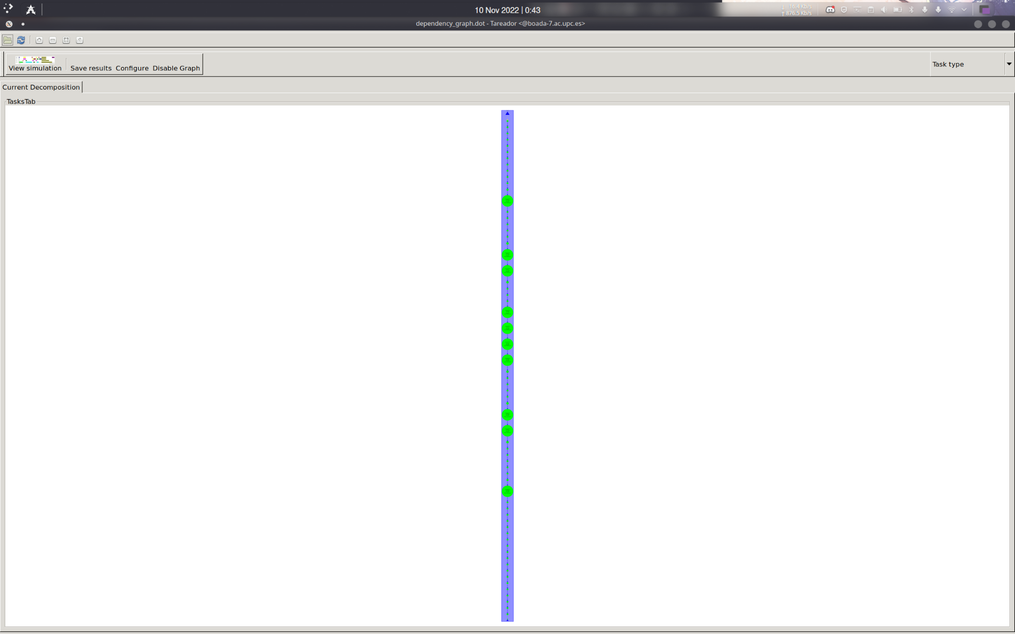



1.2.1 Graph Analysis

Figure 3 corresponds to the mandel-tar execution for *Tareador* using the flag -d. We can see that, unlike the previous task dependence graph, this one shows the tasks sequentially, but their size is still the same as before so the imbalance is unchanged.

1.2.2 Serialization discussion

In order to know what is causing this serialization we checked in the edges of the graph the real dependency. We found out a global variable, which *Tareador* named X11_COLOR_fake, is causing the dependencies between all the tasks, which makes them be executed sequentially even though they are parallelizable. This is shown in figure 4.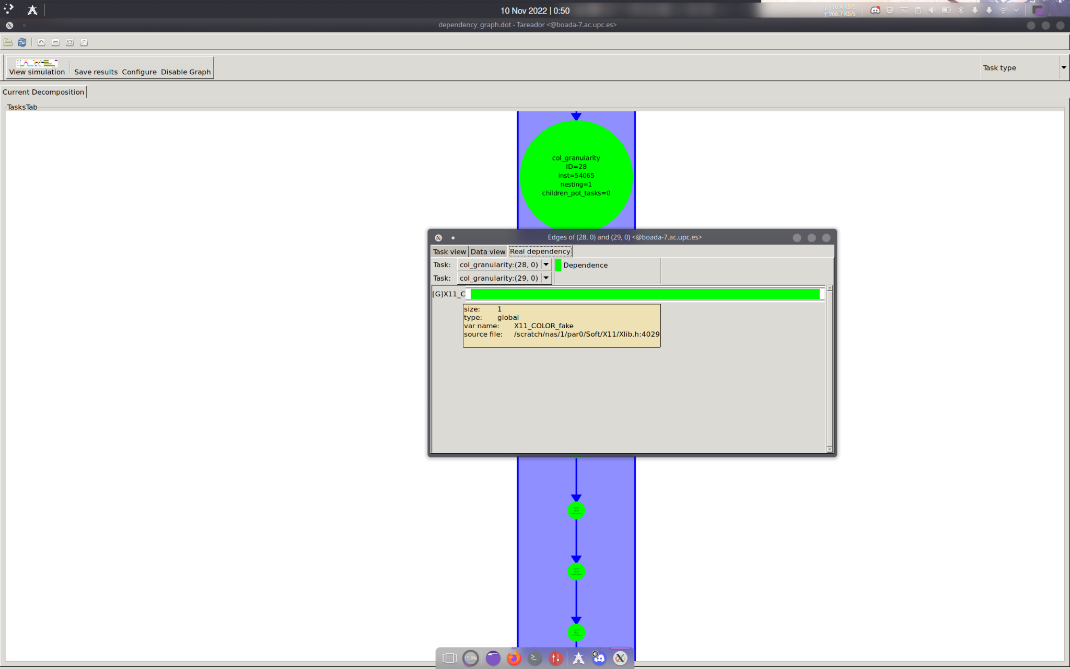

The fragment of the code below in section 1.2.3 is only executed when the option -d is chosen. The functions inside the if condition are from a library, one of which writes pixel for pixel the display. This is done sequentially, that’s why it takes so much time to execute the program when using the -d option and the reason why *Tareador* shows us the parallelizable tasks now depend on another one.

1.2.3 Solution to serialization with OpenMP

Writing #pragma omp nowait is the solution to this problem, which is also shown in the code below. With this solution *Tareador* shows us the same task dependence graph as executing mandel–tar without options, where all tasks are parallelized. See the code below to check the solution.

…

if (output2display) {

/* Scale color and display point */

long color = (long) ((k-1) * scale_color) + min_color;

if (setup_return == EXIT_SUCCESS) {

#pragma omp critical

{

XSetForeground (display, gc, color);

XDrawPoint (display, win, gc, col, row);

} } } …

**1.3 Execution of mandel-tar.c using flag -h**

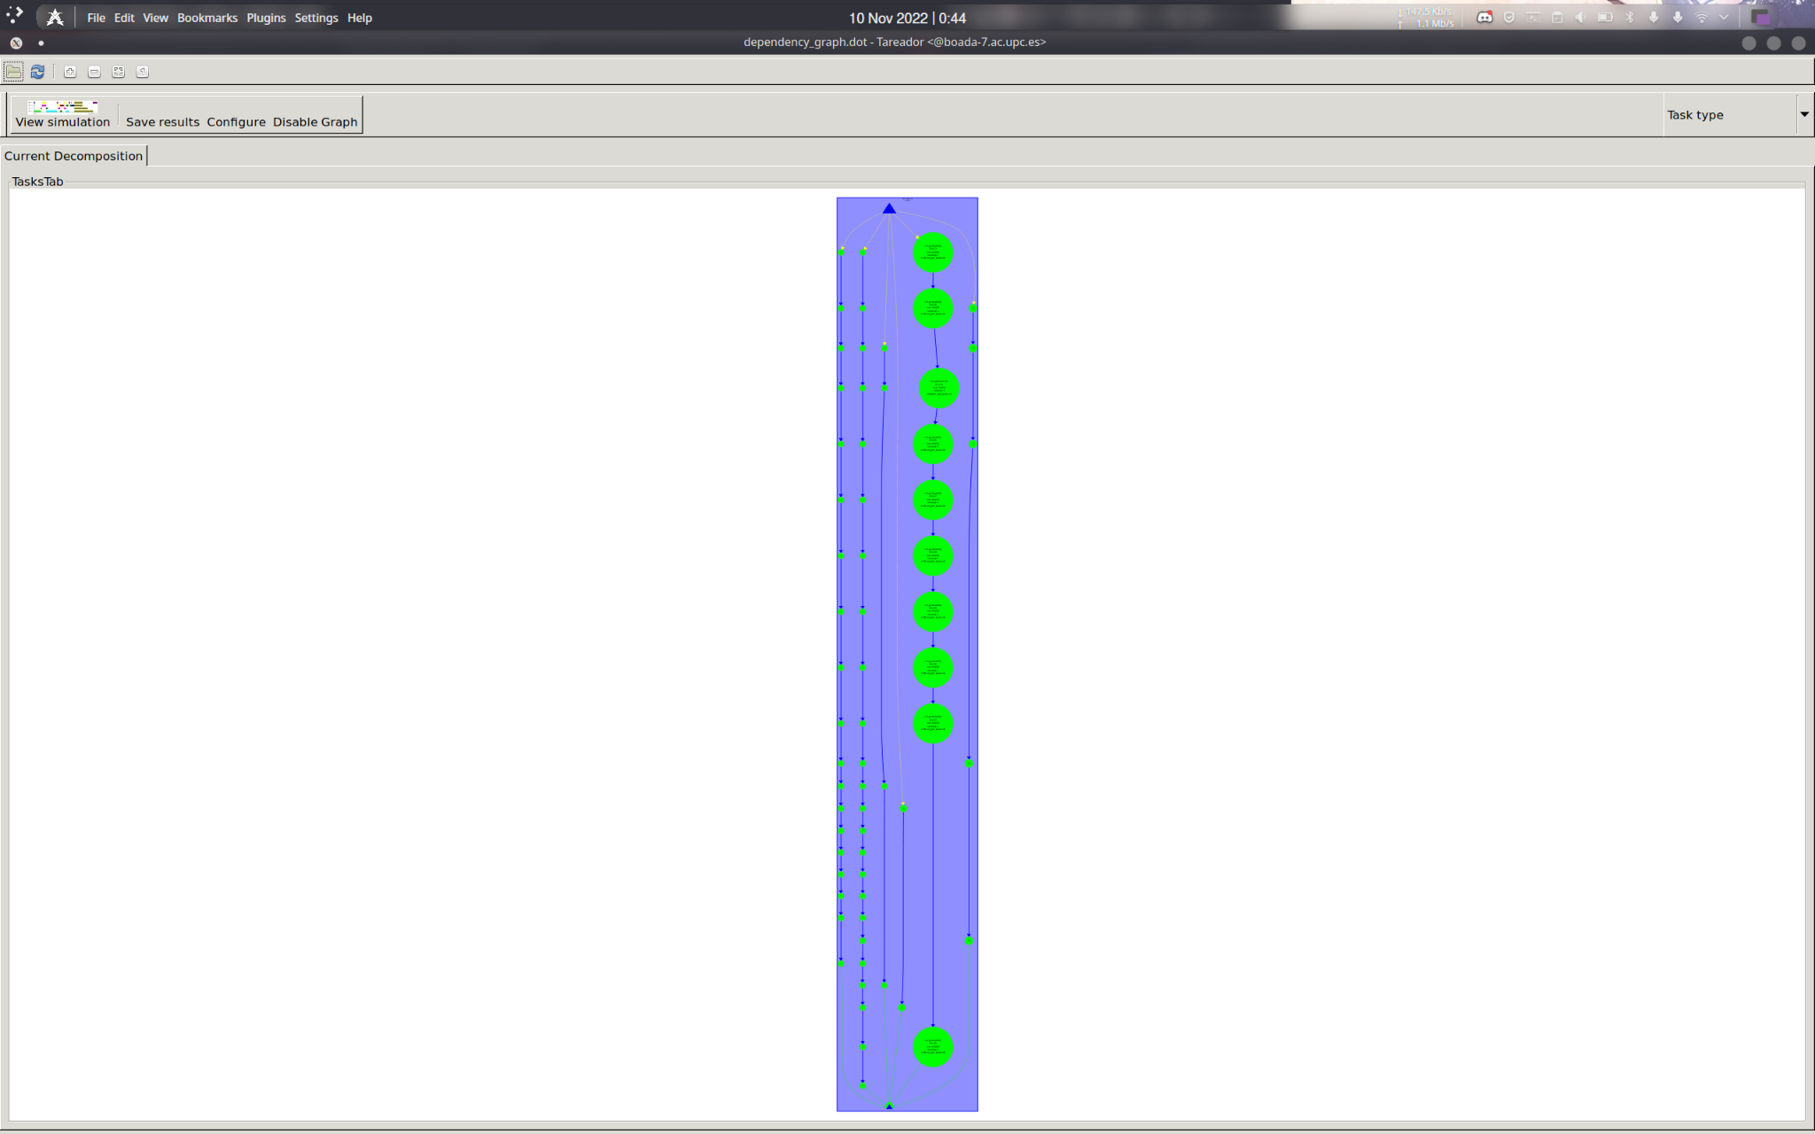

1.3.1 Graph Analysis

This is the same situation as using flag -d, there’s a variable that makes parallelizable tasks depend on another one, making the execution of our code sequential. The difference now is that, even though the code is also executed sequentially, some of the heavier tasks depend on another heavy task. This is shown in figure 5, where each chain of tasks represents the dependencies between the accesses to histogram[k-1].

1.3.2 Serialization discussion

We followed the same logic for this task dependence graph for option -h and checked its edges. In this case, the variable that makes the code sequential is named uncast of type heap (see figure 6 below).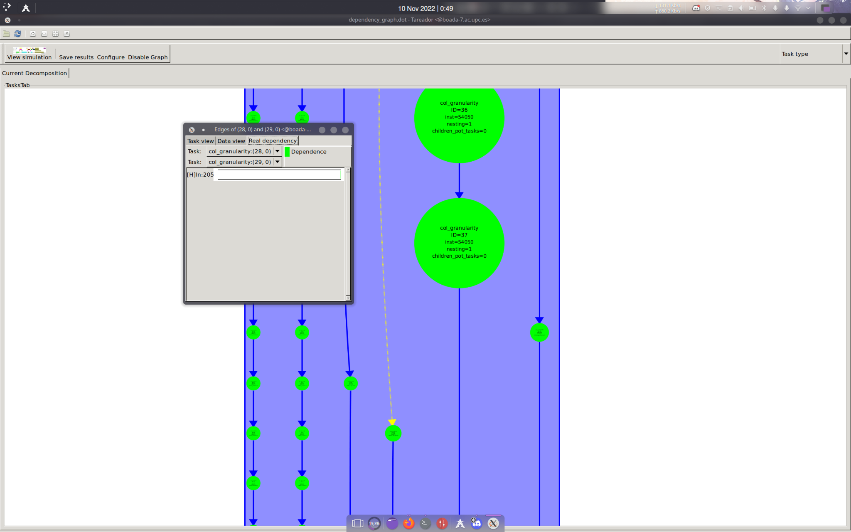

Reading the code we see a portion that is only executed when option -h is used, and this is verified with variable output2histogram. It makes the execution be sequential, because we access the vector histogram sequentially one position after the other.

1.3.3 Solution to serialization with OpenMP

**1. Point strategy implementation using tasks**

//fitxer mandel-omp.c origianl amb el critical i el atomic com a optimitzacions. Copio del que teniem escrit al full de sota que va dir el 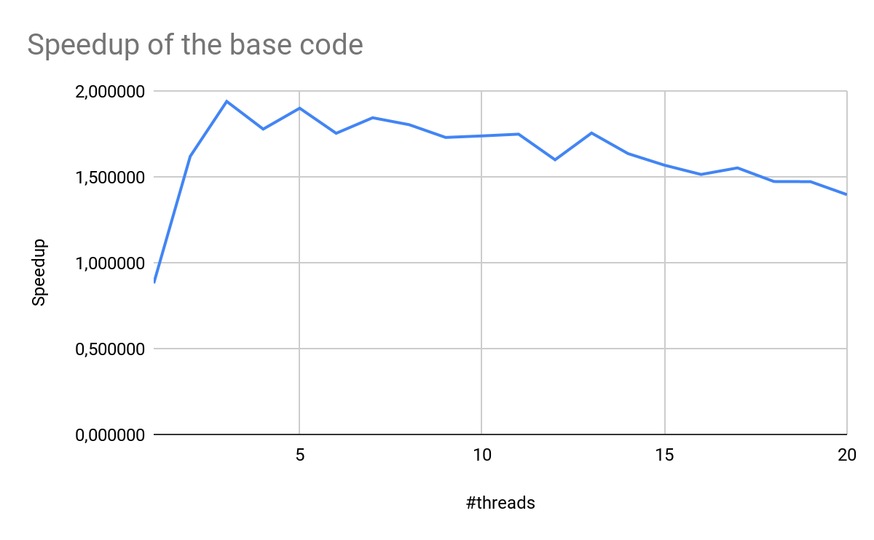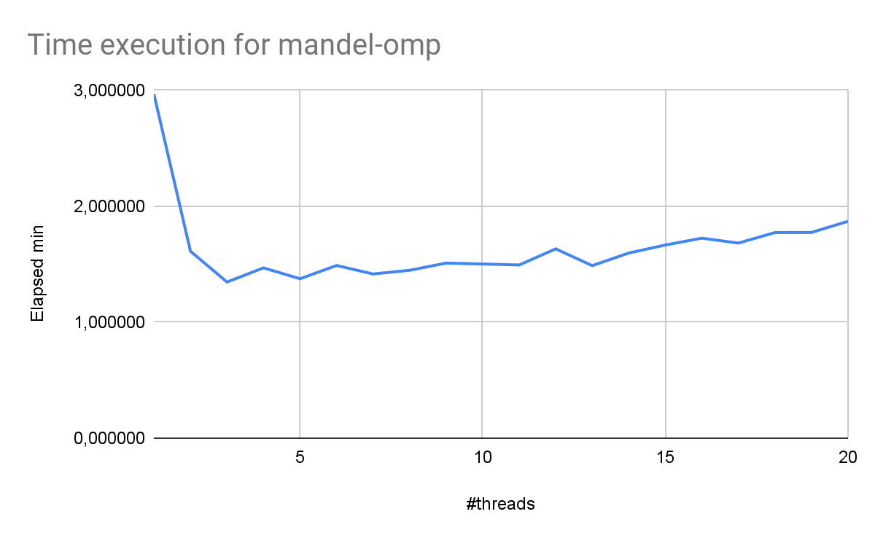

conclusions: el speedup no funcoina be. . Sha de veure a la taula

make: 'mandel-seq' is up to date.

make: 'mandel-omp' is up to date.

Executing mandel-seq sequentially

Run 0...Elapsed time = 2.607449

Run 1...Elapsed time = 2.612795

Run 2...Elapsed time = 2.612108

ELAPSED TIME MIN OF 3 EXECUTIONS =2.607449

mandel-omp 1 20 3

Starting OpenMP executions...

Executing mandel-omp with 1 threads

Run 0...Elapsed time = 2.967796

Run 1...Elapsed time = 2.970036

Run 2...Elapsed time = 2.967594

ELAPSED TIME MIN OF 3 EXECUTIONS =2.967594

Executing mandel-omp with 2 threads

Run 0...Elapsed time = 1.629440

Run 1...Elapsed time = 1.632965

Run 2...Elapsed time = 1.620811

ELAPSED TIME MIN OF 3 EXECUTIONS =1.620811

Executing mandel-omp with 3 threads

Run 0...Elapsed time = 1.380806

Run 1...Elapsed time = 1.432131

Run 2...Elapsed time = 1.463838

ELAPSED TIME MIN OF 3 EXECUTIONS =1.380806

Executing mandel-omp with 4 threads

Run 0...Elapsed time = 1.514774

Run 1...Elapsed time = 1.442650

Run 2...Elapsed time = 1.521002

ELAPSED TIME MIN OF 3 EXECUTIONS =1.442650

Executing mandel-omp with 5 threads

Run 0...Elapsed time = 1.406101

Run 1...Elapsed time = 1.373618

Run 2...Elapsed time = 1.422241

ELAPSED TIME MIN OF 3 EXECUTIONS =1.373618

Executing mandel-omp with 6 threads

Run 0...Elapsed time = 1.524149

Run 1...Elapsed time = 1.540987

Run 2...Elapsed time = 1.483137

ELAPSED TIME MIN OF 3 EXECUTIONS =1.483137

Executing mandel-omp with 7 threads

Run 0...Elapsed time = 1.424452

Run 1...Elapsed time = 1.423655

Run 2...Elapsed time = 1.445816

ELAPSED TIME MIN OF 3 EXECUTIONS =1.423655

Executing mandel-omp with 8 threads

Run 0...Elapsed time = 1.453293

Run 1...Elapsed time = 1.490221

Run 2...Elapsed time = 1.475250

ELAPSED TIME MIN OF 3 EXECUTIONS =1.453293

Executing mandel-omp with 9 threads

Run 0...Elapsed time = 1.516040

Run 1...Elapsed time = 1.478456

Run 2...Elapsed time = 1.520367

ELAPSED TIME MIN OF 3 EXECUTIONS =1.478456

Executing mandel-omp with 10 threads

Run 0...Elapsed time = 1.514485

Run 1...Elapsed time = 1.504713

Run 2...Elapsed time = 1.528736

ELAPSED TIME MIN OF 3 EXECUTIONS =1.504713

Executing mandel-omp with 11 threads

Run 0...Elapsed time = 1.533935

Run 1...Elapsed time = 1.525739

Run 2...Elapsed time = 1.539707

ELAPSED TIME MIN OF 3 EXECUTIONS =1.525739

Executing mandel-omp with 12 threads

Run 0...Elapsed time = 1.516490

Run 1...Elapsed time = 1.652558

Run 2...Elapsed time = 1.688536

ELAPSED TIME MIN OF 3 EXECUTIONS =1.516490

Executing mandel-omp with 13 threads

Run 0...Elapsed time = 1.545798

Run 1...Elapsed time = 1.524688

Run 2...Elapsed time = 1.609556

ELAPSED TIME MIN OF 3 EXECUTIONS =1.524688

Executing mandel-omp with 14 threads

Run 0...Elapsed time = 1.718136

Run 1...Elapsed time = 1.670105

Run 2...Elapsed time = 1.643928

ELAPSED TIME MIN OF 3 EXECUTIONS =1.643928

Executing mandel-omp with 15 threads

Run 0...Elapsed time = 1.690923

Run 1...Elapsed time = 1.689535

Run 2...Elapsed time = 1.694433

ELAPSED TIME MIN OF 3 EXECUTIONS =1.689535

Executing mandel-omp with 16 threads

Run 0...Elapsed time = 1.716095

Run 1...Elapsed time = 1.761670

Run 2...Elapsed time = 1.820508

ELAPSED TIME MIN OF 3 EXECUTIONS =1.716095

Executing mandel-omp with 17 threads

Run 0...Elapsed time = 1.729341

Run 1...Elapsed time = 1.760967

Run 2...Elapsed time = 1.687576

ELAPSED TIME MIN OF 3 EXECUTIONS =1.687576

Executing mandel-omp with 18 threads

Run 0...Elapsed time = 1.970642

Run 1...Elapsed time = 1.779902

Run 2...Elapsed time = 1.824226

ELAPSED TIME MIN OF 3 EXECUTIONS =1.779902

Executing mandel-omp with 19 threads

Run 0...Elapsed time = 1.821544

Run 1...Elapsed time = 1.761749

Run 2...Elapsed time = 1.807641

ELAPSED TIME MIN OF 3 EXECUTIONS =1.761749

Executing mandel-omp with 20 threads

Run 0...Elapsed time = 1.980055

Run 1...Elapsed time = 1.862589

Run 2...Elapsed time = 1.916657

ELAPSED TIME MIN OF 3 EXECUTIONS =1.862589

Resultat de l'experiment (tambe es troben a ./elapsed-boada-11.txt i ./speedup-boada-11.txt )

//els valors dels gràfics es veuen millor en forma de taula, tot i que al fitxer apareixen simplement els valors en dues columnes

| #threads | Elapsed min |
| --- | --- |
| 1 | 2,966506 |
| 2 | 1,612094 |
| 3 | 1,346258 |
| 4 | 1,468426 |
| 5 | 1,374311 |
| 6 | 1,488779 |
| 7 | 1,415782 |
| 8 | 1,447476 |
| 9 | 1,509646 |
| 10 | 1,501862 |
| 11 | 1,493176 |
| 12 | 1,632445 |
| 13 | 1,487451 |
| 14 | 1,596570 |
| 15 | 1,665312 |
| 16 | 1,724529 |
| 17 | 1,682151 |
| 18 | 1,772812 |
| 19 | 1,773767 |
| 20 | 1,869757 |

| #threads | Speedup |
| --- | --- |
| 1 | 0,879753 |
| 2 | 1,618884 |
| 3 | 1,938553 |
| 4 | 1,777272 |
| 5 | 1,898983 |
| 6 | 1,752975 |
| 7 | 1,843358 |
| 8 | 1,802996 |
| 9 | 1,728745 |
| 10 | 1,737705 |
| 11 | 1,747813 |
| 12 | 1,598702 |
| 13 | 1,754540 |
| 14 | 1,634625 |
| 15 | 1,567150 |
| 16 | 1,513337 |
| 17 | 1,551462 |
| 18 | 1,472121 |
| 19 | 1,471328 |
| 20 | 1,395793 |

**1.1 Modelfactors**

**For the deliverable:** Is the speed–up appropriate? Is the scalability appropriate? Include the Modelfactor tables and the PostScript file generated.

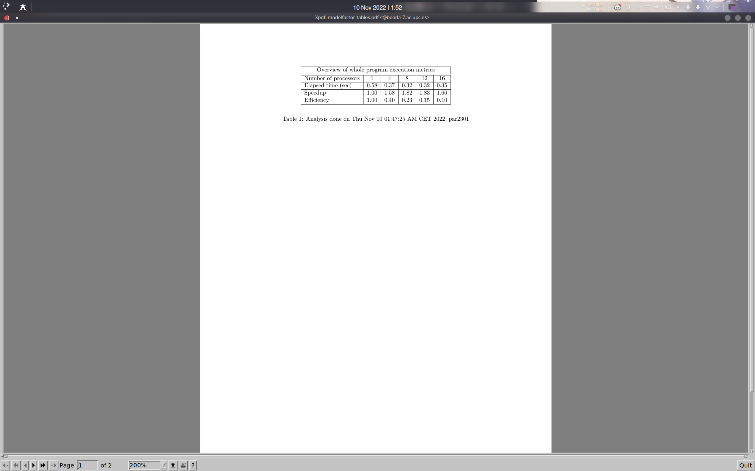

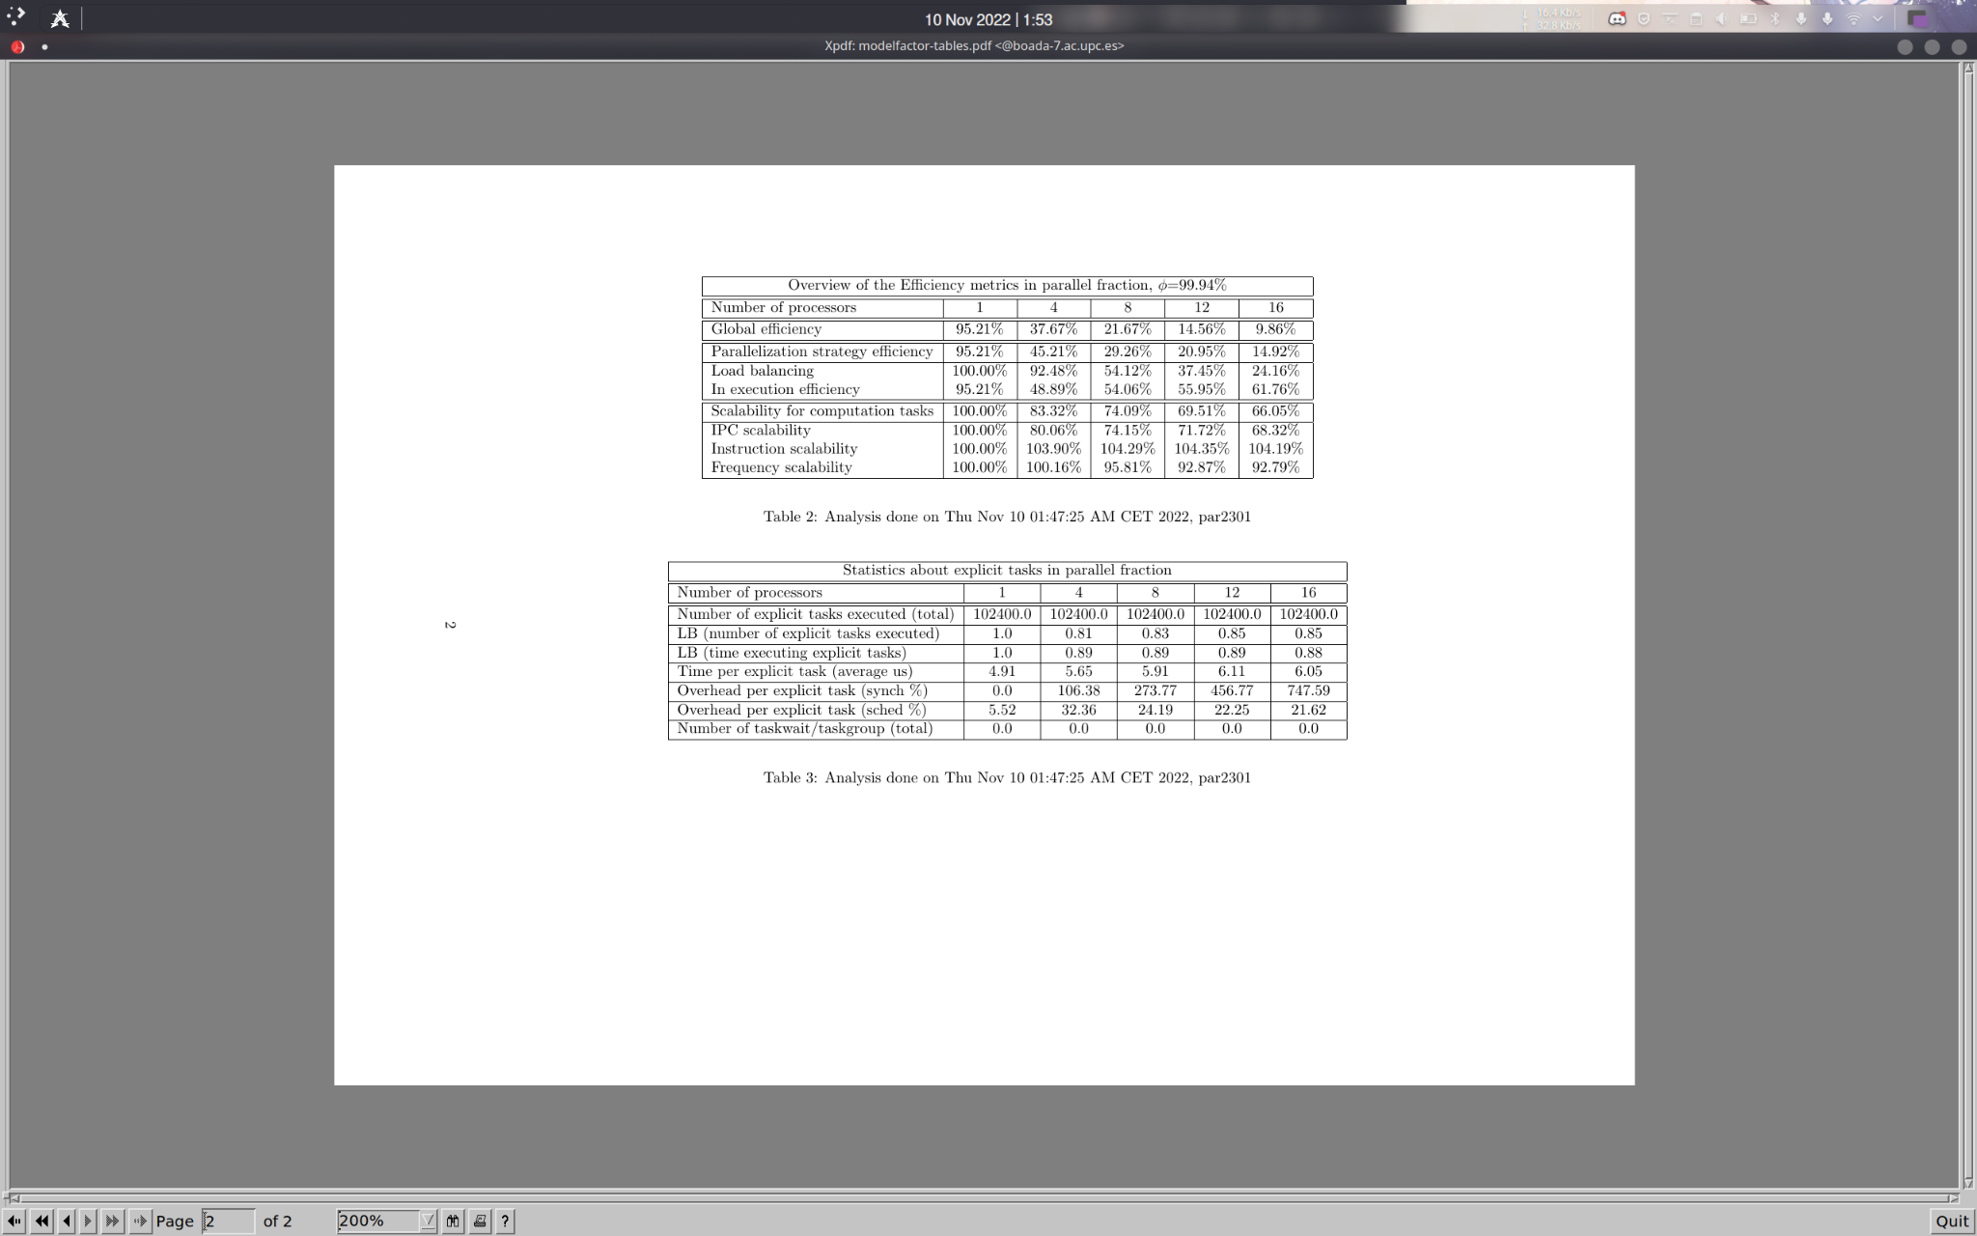

fraccio paralela 99%: no hem deixat un tros de codi que no hem sequencialitzat.

La mes petita es 20%, load balancing, es perque hi ha punts que necessitem moltes iteracions per acabar.

Tenim 10000, moltes tasquesper nomes 16 threads.

800% overhead de cada tasca explicita.

solucio: reduir numero tasques.

demanen taskes amb punts:

12 threads original version:

**1.2 Paraver**

**For the deliverable:** Which threads are creating and executing the explicit tasks? Is one of the threads devoted to create them, and therefore executing much less? If yes, this should be a clear contributor to load unbalance, right?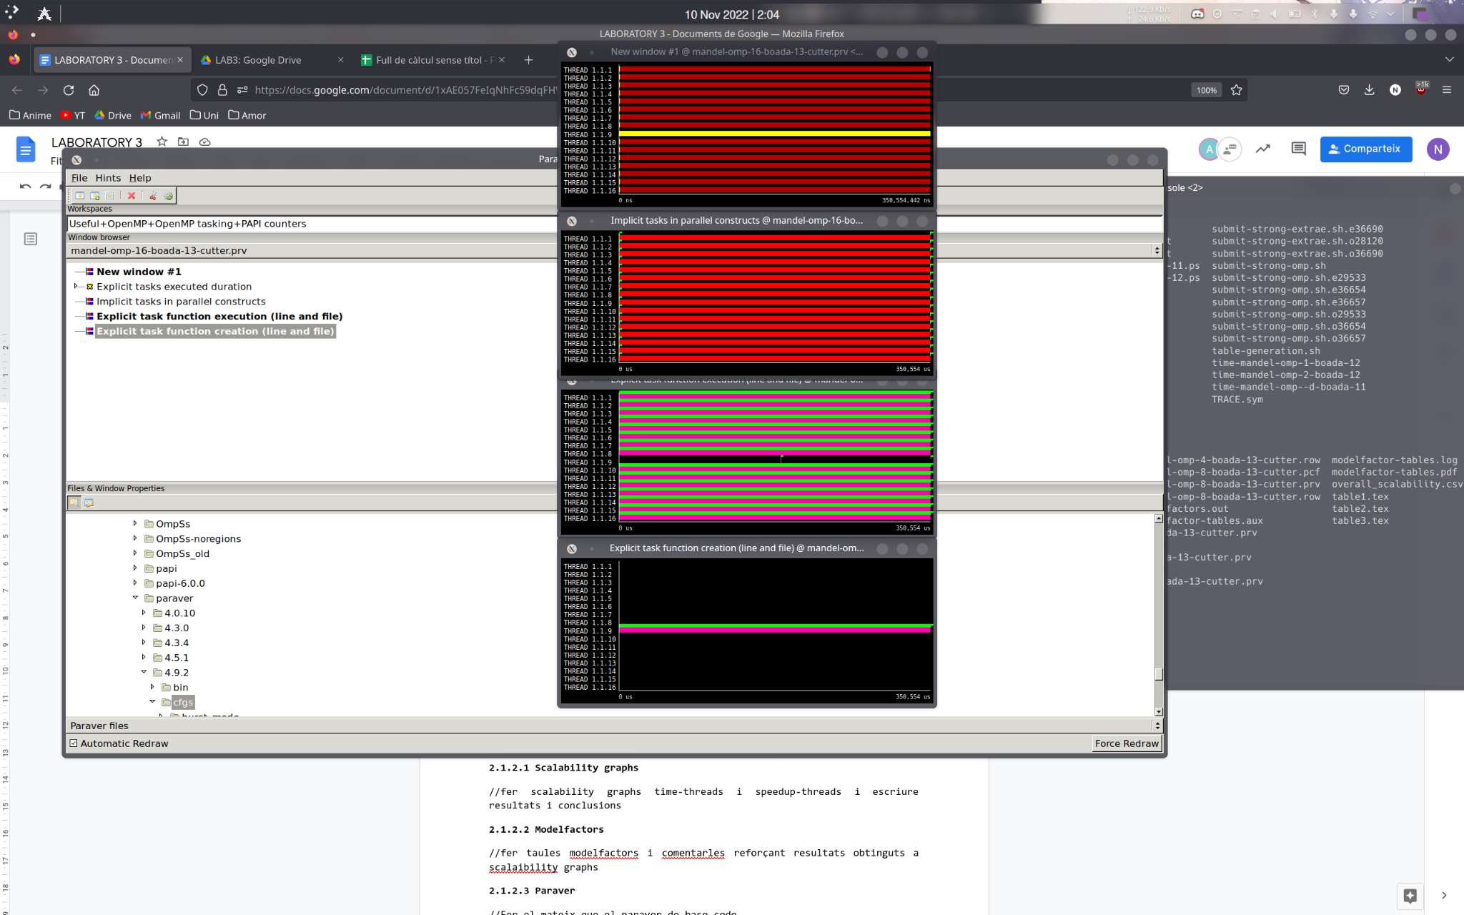

**For the deliverable:** Based on the Modelfactors tables, performance plots, Paraver timelines and profiles, do you think the granularity of the tasks is appropriate for this parallelization strategy? Important: Take note of all the relevant information in order to draw some conclusions about the behaviour of this code version. You will have to include them in the deliverable for this laboratory assignment and support with the appropriate Paraver window captures, modelfactors tables and performance plots.

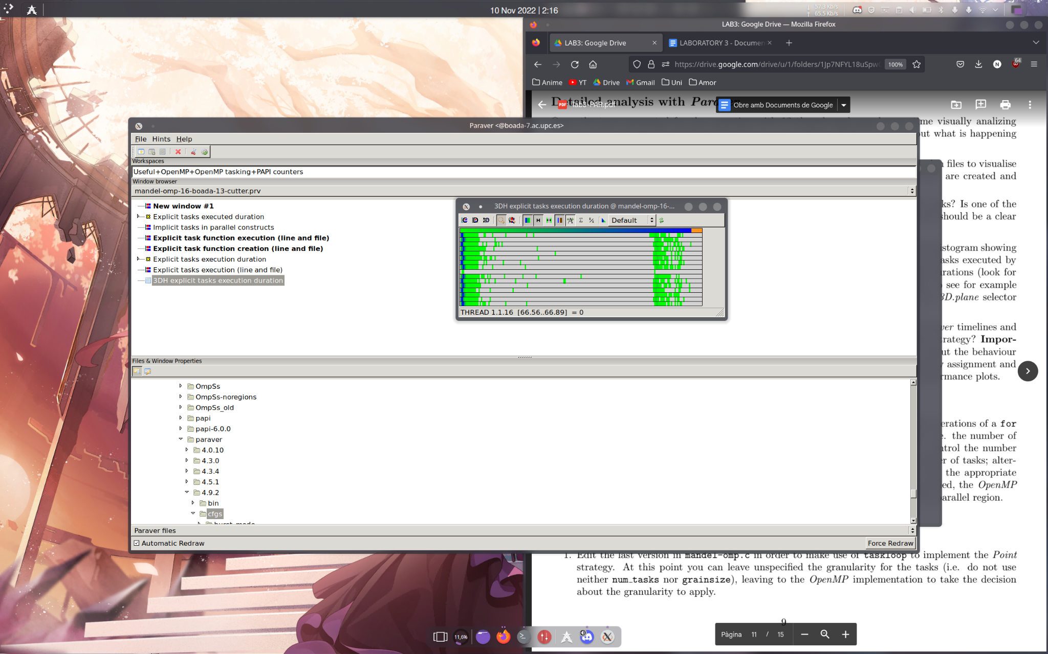

Tot es sincronitxacio menys un thread. fer fit time scale -> parallel construct. COPIAR I ENGANXAR format.una a sobre laltra -> ezxplicit taask function execution -> expicit tasl function creation rosa: creant tasques, verd: flags thread 1: no sexecuta menys al mig, perque es quan sexecuten els points del mandelbrot set que necessiten mes iteracions per executarse. → (3HD explicit tasks execution duration: hi ha tasques que duren molt poc, es correspon a les tasques verdes daltres grafics -> explicit task function execution (time and line) -> explicit tasks execution duration (sense el 3HD) ) Es fa amb el hint

**1.3 Optimization: point strategy using the OpenMP clause taskloop**

//Explicar modificacions del codi i foto del codi: hem afegit #pragma omp taskloop abans del for de columns per ferho a nivell de punt.

…

// Calculate points and generate appropriate output

#pragma omp parallel

#pragma omp single

for (int row = 0; row < height; ++row) {

#pragma omp taskloop

for (int col = 0; col < width; ++col) {

#pragma omp task firstprivate(row, col)

{

complex z, c;

z.real = z.imag = 0;

…

//fer scalability graphs time-threads i speedup-threads i escriure resultats i conclusions

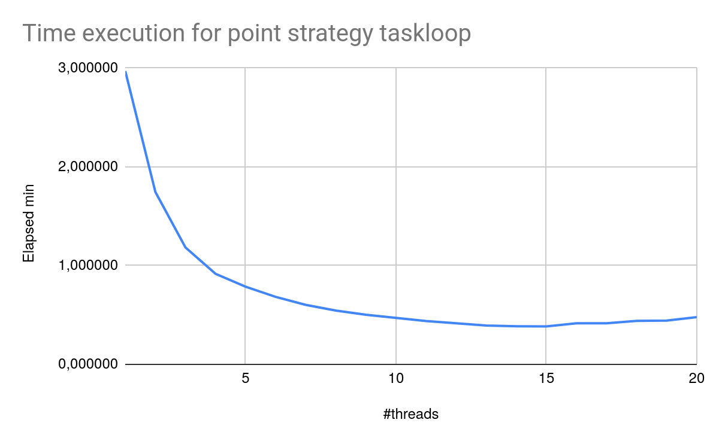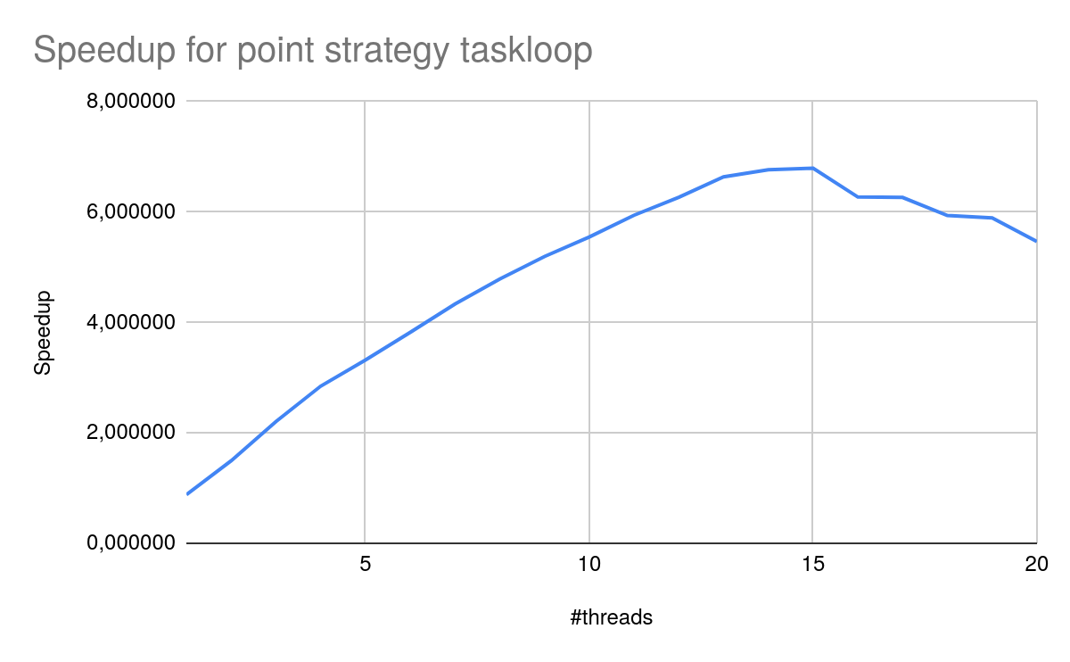

**1.3.1 Modelfactors**

//fer taules modelfactors i comentarles reforçant resultats obtinguts a scalaibility graphs

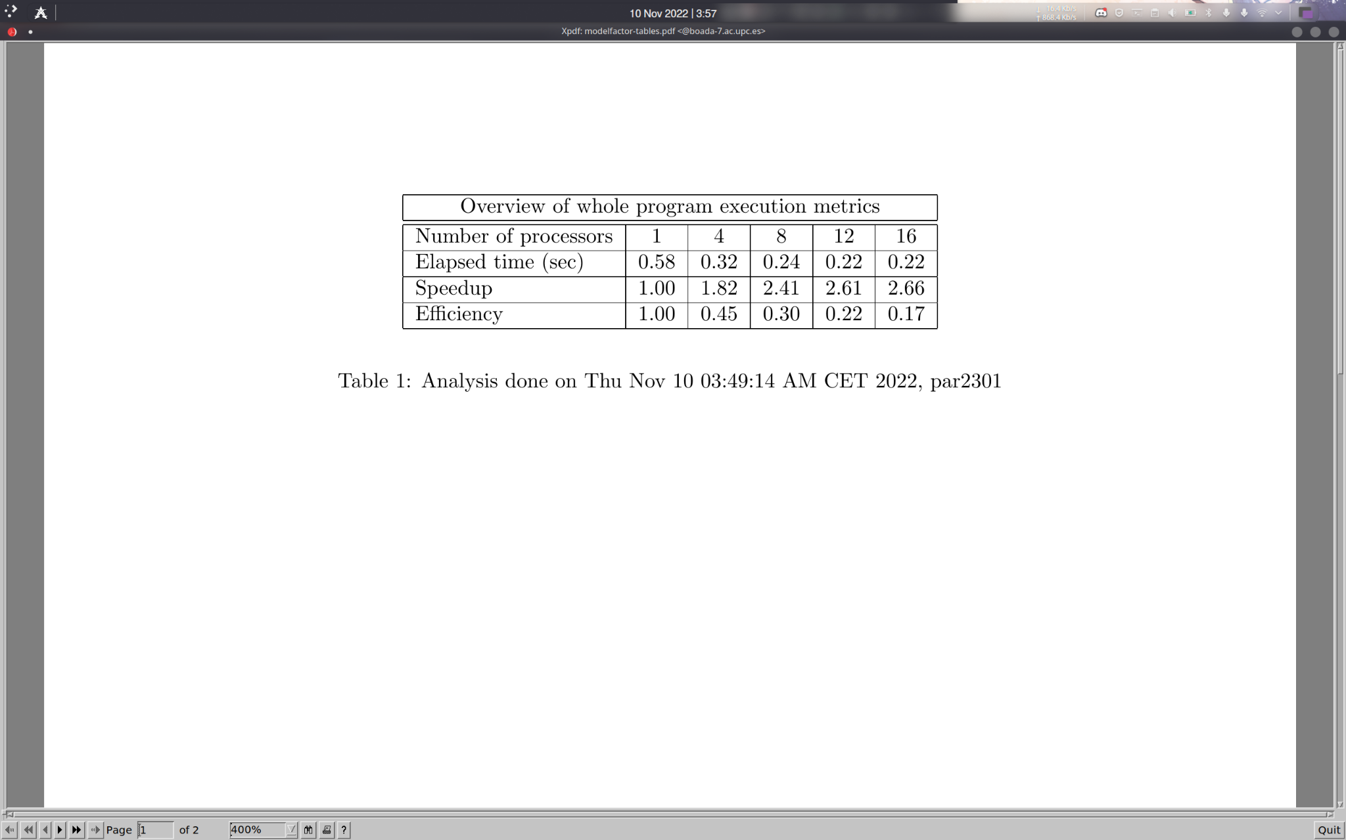

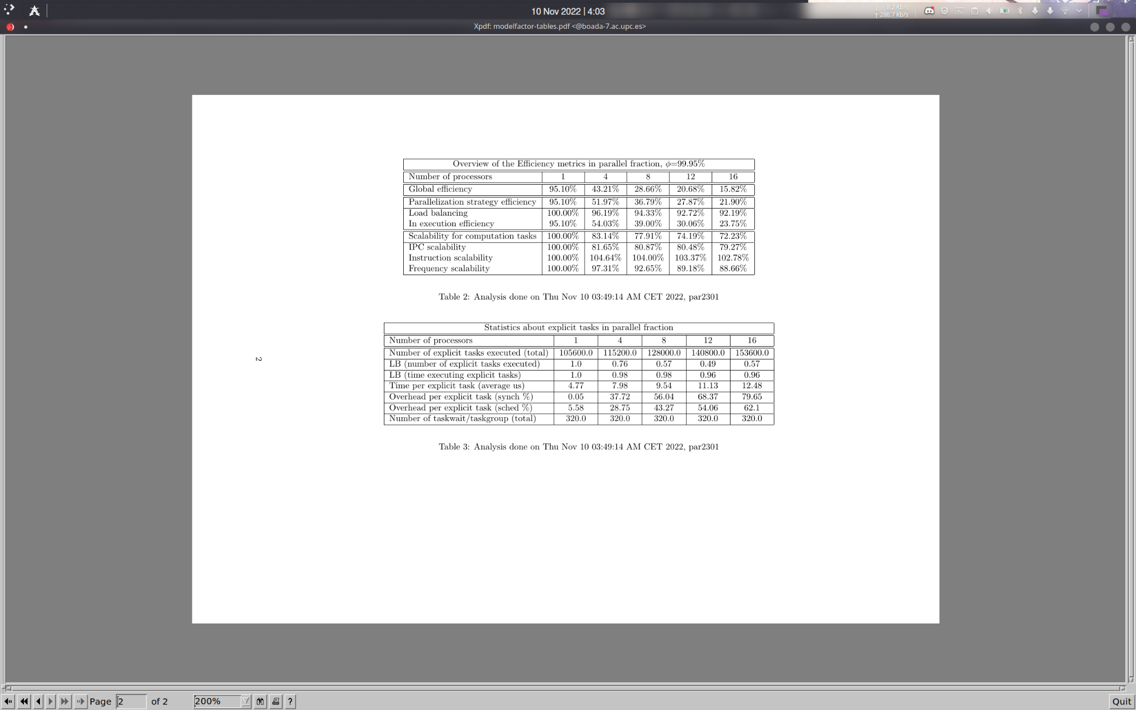

**For the deliverable:** Is the version with taskloop performing better than the last version based on the use of task?

**For the deliverable:** Do you notice a relevant change in the two metrics that contribute to the parallelization strategy efficiency? Should you blame to ”load balancing” or to ”in execution efficiency”? Scan the information provided in the third table that is included in the modelfactor-tables.pdf file. What can you tell now from the total number of tasks generated and the new average execution time for explicit tasks and the synchronization and scheduling overheads percentage? How many tasks are executed per taskloop? Is the task granularity better? But notice that task synchronization still takes a big %.

**For the deliverable:** Include Modelfactor tables in the deliverable. Why are there now task synchronizations in the execution? Where are these task synchronisations happening? Continue with the following section to be able to answer these questions.

**1.3.2 Detailed Analysis and possible optimization: Paraver**

//Fer el mateix que el paraver de base code

**For the deliverable:** Do you think these task barriers are necessary? If your answer was negative, you can add the nogroup clause to the taskloop clause in order to eliminate the implicit taskgroup. Edit the code and submit again the submit-strong-extrae.sh script. Has the scalability improved? What about task granularity and overheads?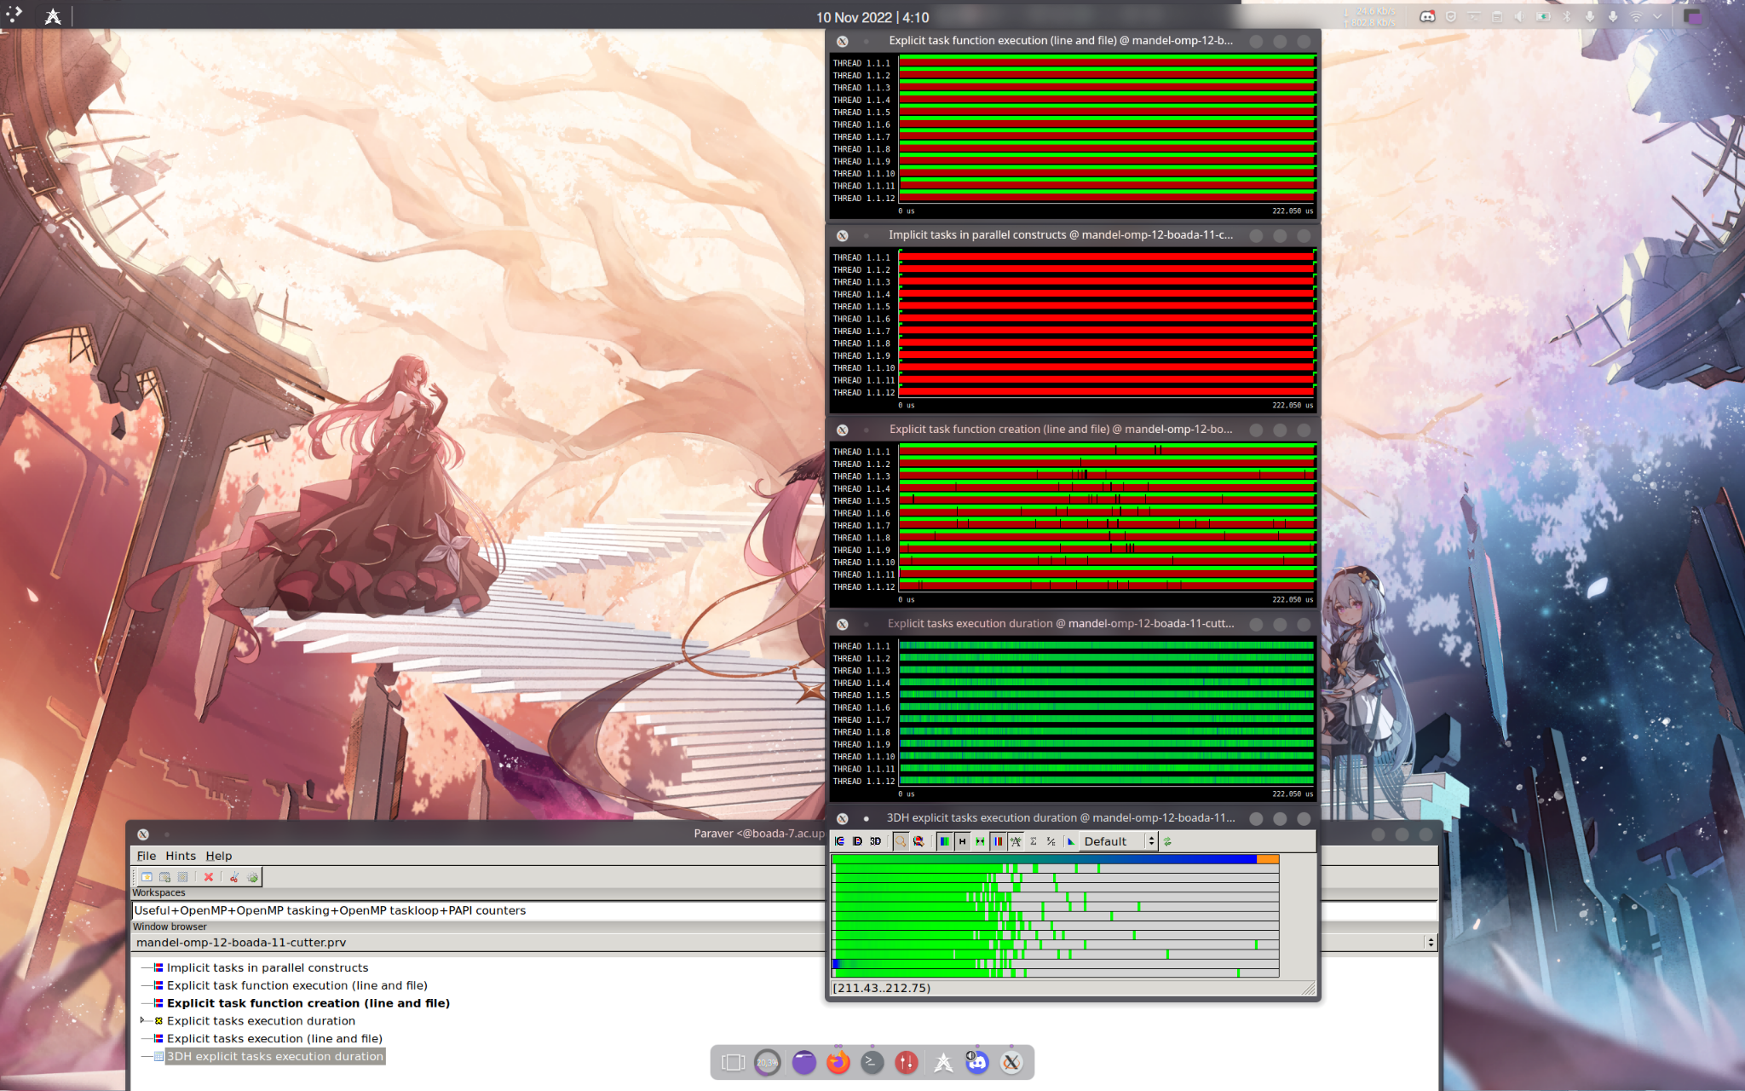

**2. Row strategy implementation**

To implement the row strategy we moved the clause #pragma omp taskloop to the line before the for loop that iterates the rows of the matrix. This way, for every row we perform a task in parallel. The modified code is:

…

// Calculate points and generate appropriate output

#pragma omp parallel

#pragma omp single

#pragma omp taskloop

for (int row = 0; row < height; ++row) {

for (int col = 0; col < width; ++col) {

#pragma omp task firstprivate(row, col)

{

complex z, c;

z.real = z.imag = 0;

…

As we can see in the elapsed time of row strategy the more threads we use the faster the program is executed. This matches the results obtained on the second graph which shows the speedup increases linearly.

There’s a big difference between point strategy scalability graphs and row strategy scalability graphs. In the first one there’s no speedup at all and the elapsed time stays more or less the same, independently of the number of threads used. On the row strategy the speedup increases linearly and the more threads used the less time it takes for the program to finish. This is due to the fact that the number of tasks of point strategy is very big, which wastes a lot of time synchronizing threads, unlike row strategy that has only eight tasks.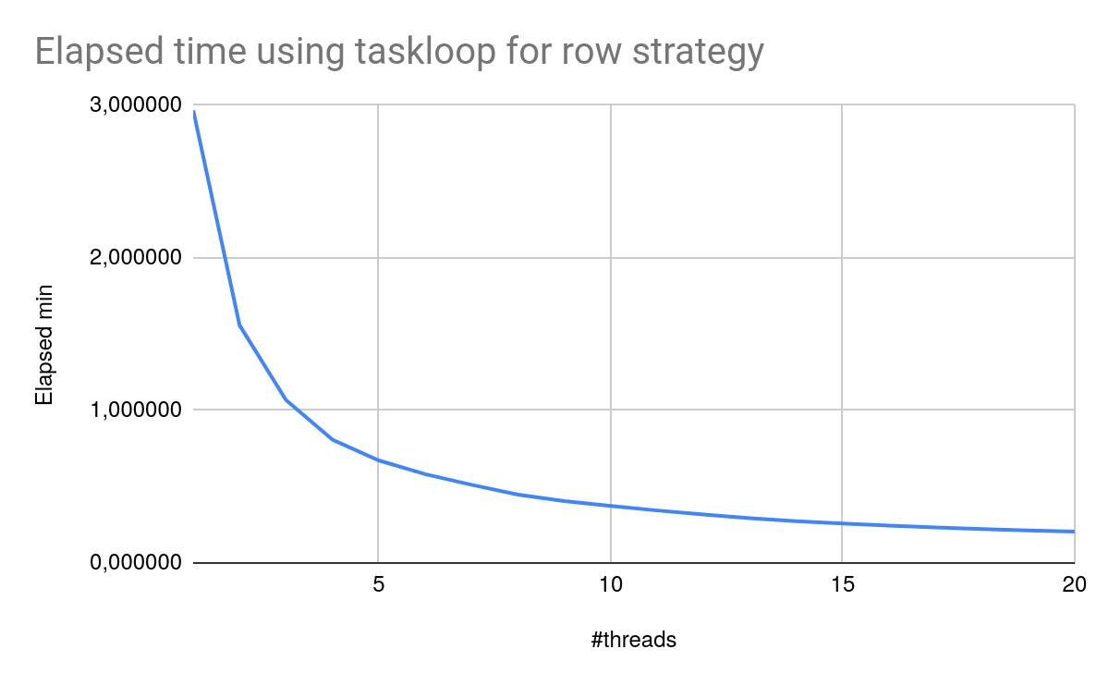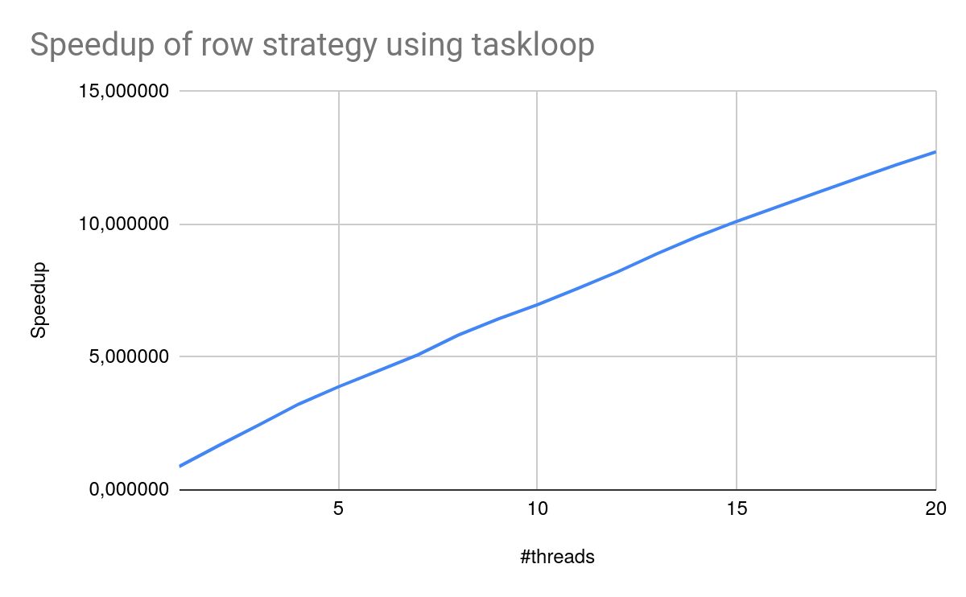

To sum up, there’s a very big load imbalance on the point strategy (there are a lot of tasks and they do only one iteration) and waste a lot of time on synchronization, that’s why using more threads doesn’t decrease the execution time. On the other hand, row strategy is more balanced having 8 tasks with a reasonable amount of iterations each.

**For the deliverable:** Support your reasoning and draw the attention to the main differences that

you observe when comparing the Row and Point granularities. Analyse the number of tasks created

vs. the number of tasks executed and their granularities. Is there any load unbalance? Any task

synchronisation to eliminate?

2.1 Modelfactors

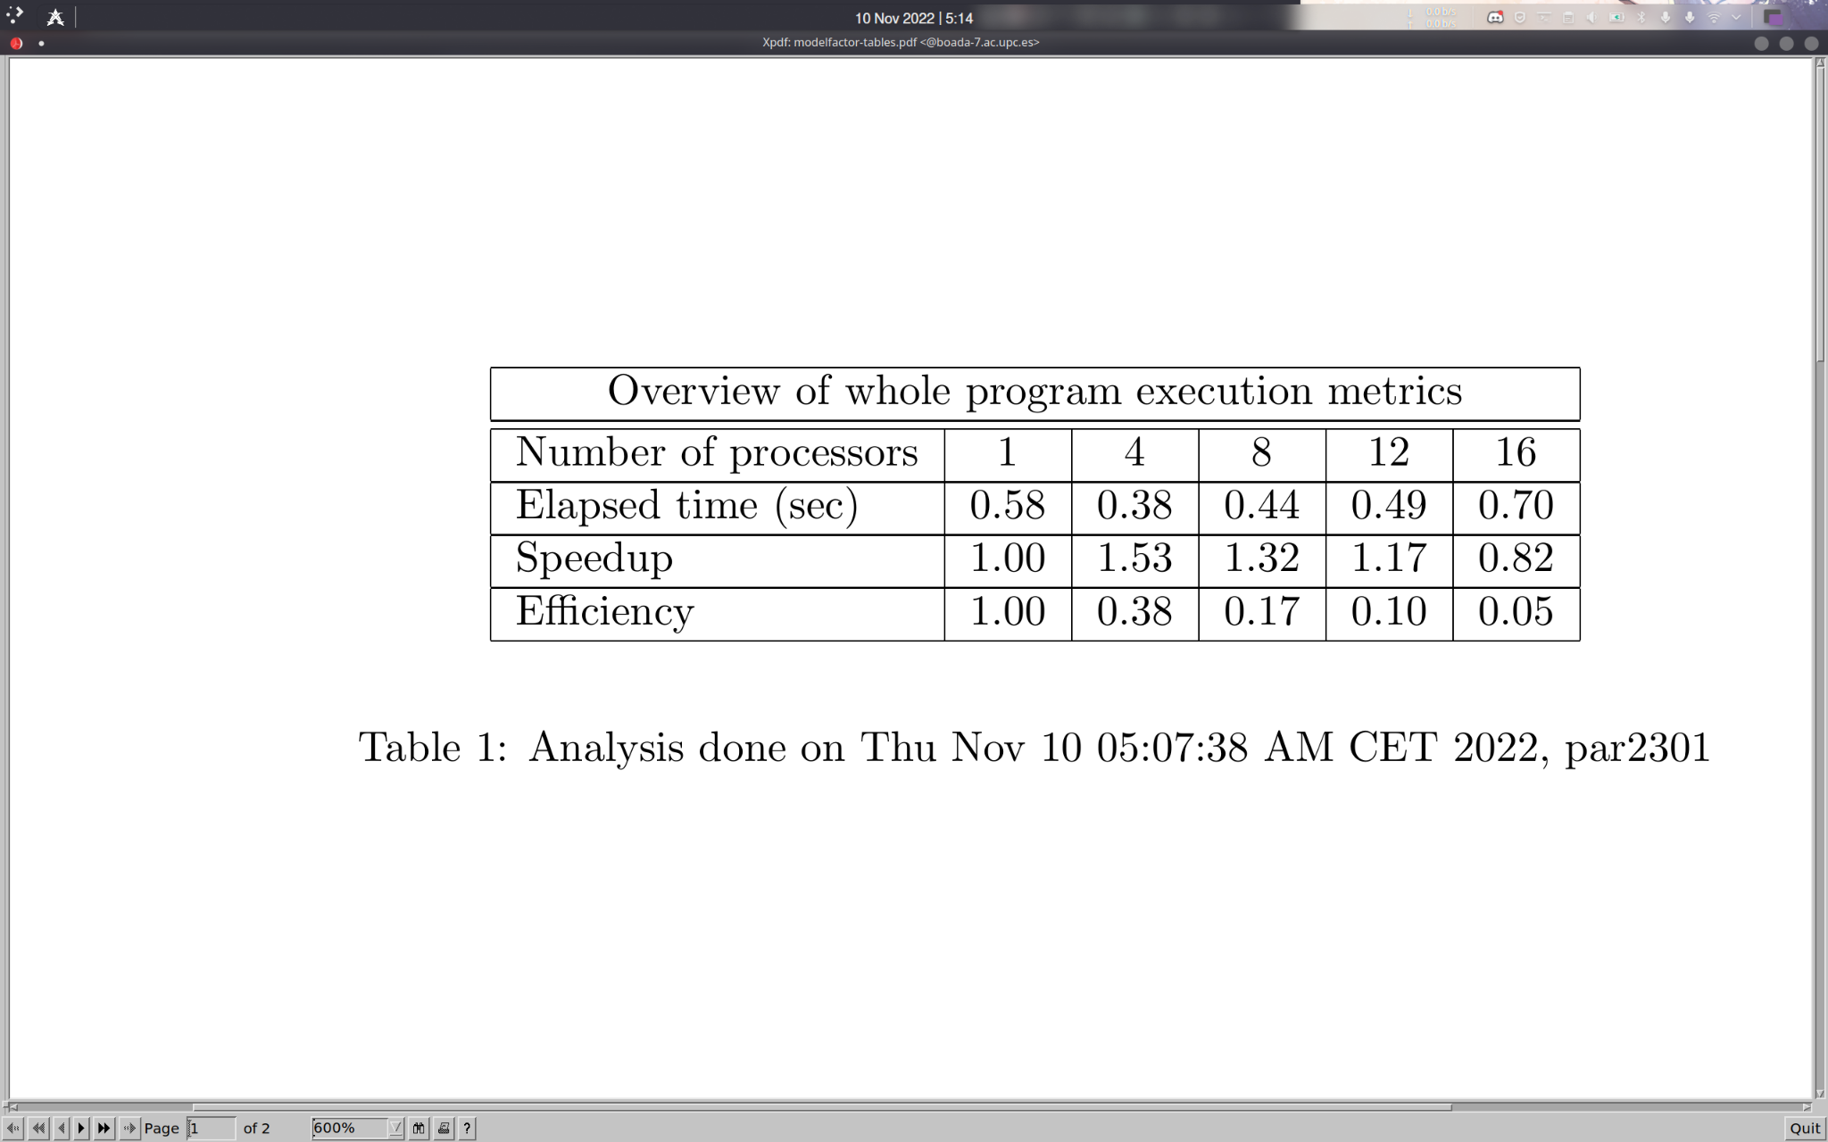

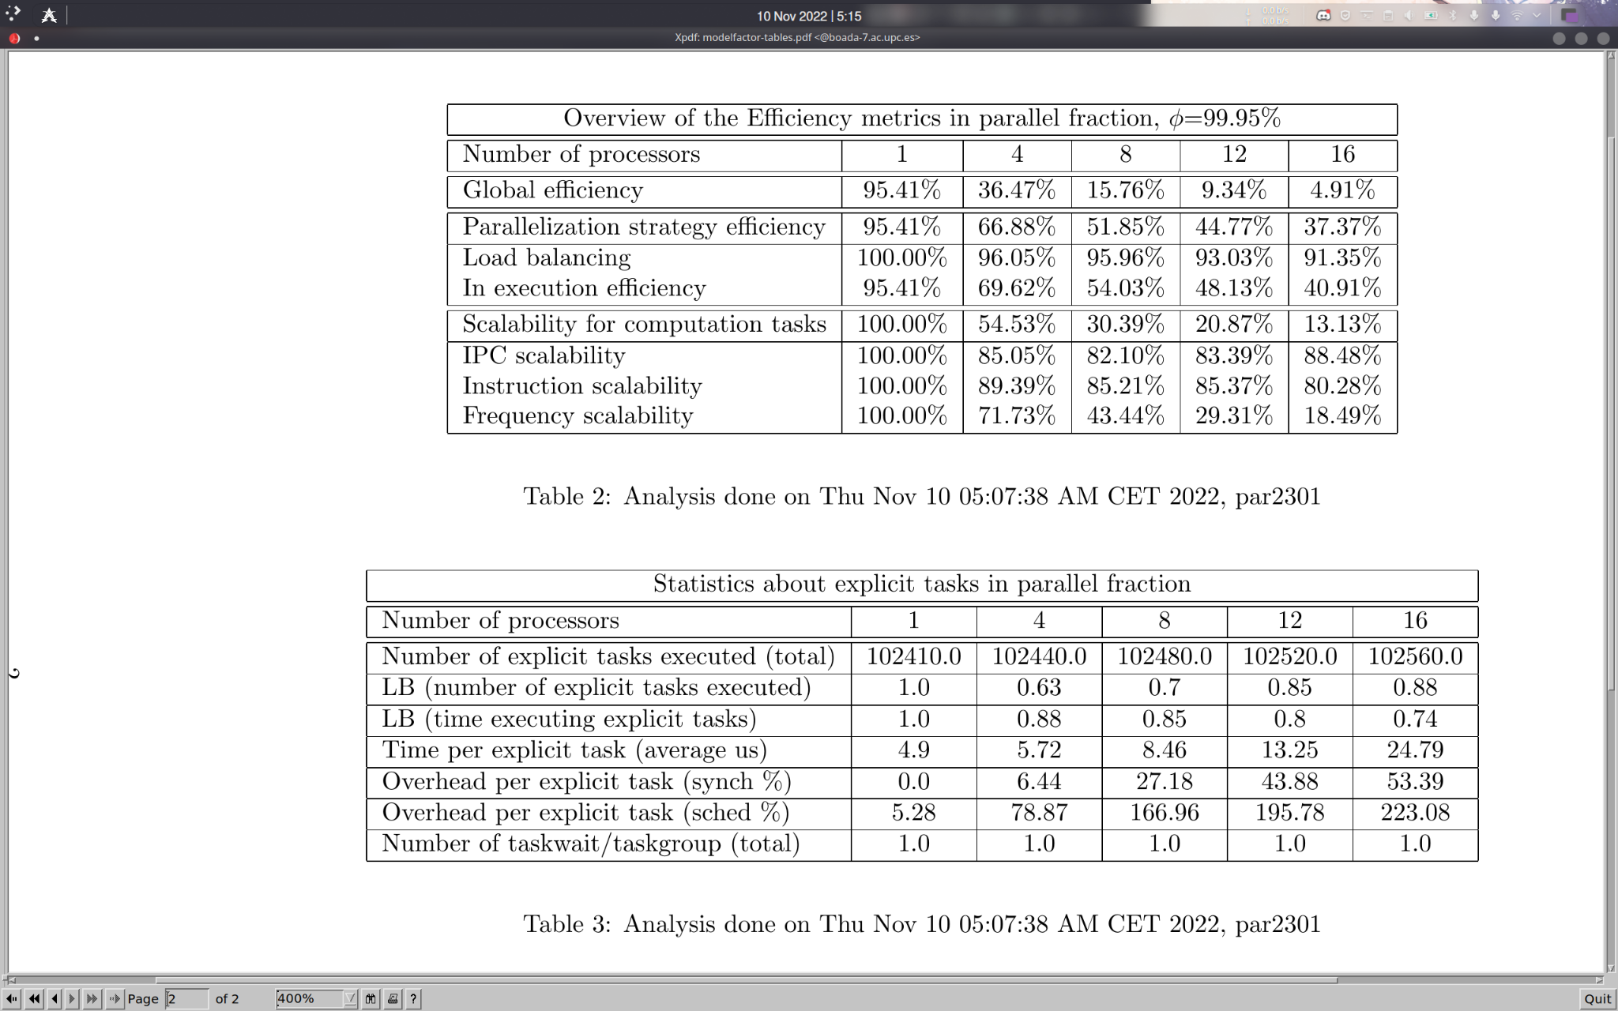

2.2 Paraver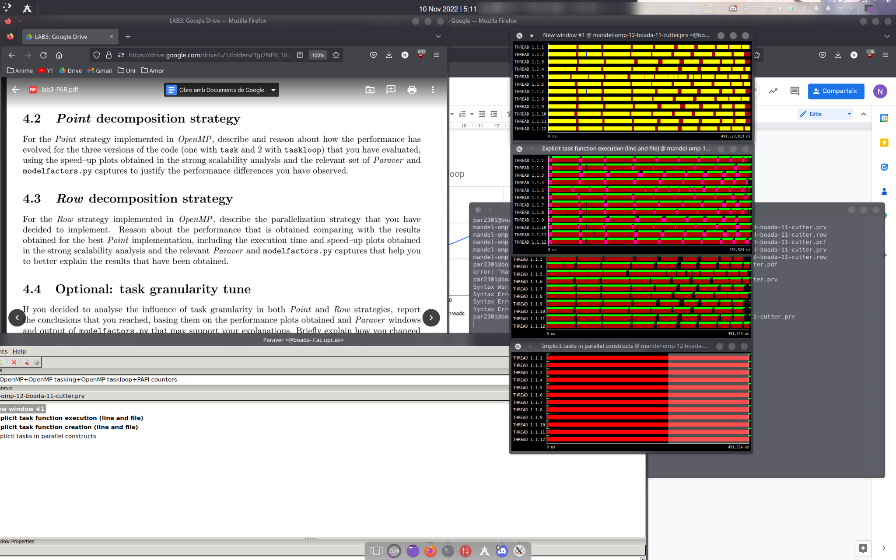

estructura: scalability graphs, taules modelfactors, paraver per a cada versio.

versions amb la base, taskloop, taskloop nogroup (punt), taskloop (row)

a nivell de columnes:

graph tim-threads (horitzpntzal)

graph speedup-threads horizontal completament

conclusions: el speedup no funcoina be. . Sha de veure a la taula

modelfactors:

fraccio paralela 99%: no hem deixat un tros de codi que no hem sequencialitzat.

La mes petita es 20%, load balancing, es perque hi ha punts que necessitem moltes iteracions per acabar.

Tenim 10000, moltes tasquesper nomes 16 threads.

800% overhead de cada tasca explicita.

solucio: reduir numero tasques.

demanen taskes amb punts:

12 threads original version:

Paraver:

Tot es sincronitxacio menys un thread. fer fit time scale -> parallel construct. COPIAR I ENGANXAR format.una a sobre laltra -> ezxplicit taask function execution -> expicit tasl function creation rosa: creant tasques, verd: flags thread 1: no sexecuta menys al mig, perque es quan sexecuten els points del mandelbrot set que necessiten mes iteracions per executarse. → (3HD explicit tasks execution duration: hi ha tasques que duren molt poc, es correspon a les tasques verdes daltres grafics -> explicit task function execution (time and line) -> explicit tasks execution duration (sense el 3HD) ) Es fa amb el hint

Unes 15 pagines

FOTO ALBERT INDEX